### 1

**Define your problem statement**

What problem are you trying to solve? Frame your problem as a How Might We statement. This will be the focus of your brainstorm.

**Before you collaborate**

A little bit of preparation goes a long way with this session. Here’s what you need to do to get going.

**10 minutes**

**5 minutes**



**2**

### Brainstorm

Write down any ideas that come to mind that address your problem statement.

**10 minutes**



**3**

### Group ideas



**TIP**

You can select a sticky note and hit the pencil [switch to sketch] icon to start drawing!

Take turns sharing your ideas while clustering similar or related notes as you go. In the last 10 minutes, give each cluster a sentence-like label. If a cluster is bigger than six sticky notes, try and see if you and break it up into smaller sub-groups.

**20 minutes**

**Group ideas**

### 4

**Prioritize**

Your team should all be on the same page about what's important moving forward. Place your ideas on this grid to determine which ideas are important and which are feasible.

**TIP**

Add customizable tags to sticky notes to make it easier to find, browse, organize, and categorize important ideas as themes within your mural.

**20 minutes**

### After you collaborate

You can export the mural as an image or pdf to share with members of your company who might find it helpful.

**TIP**

Participants can use their cursors to point at where sticky notes should go on the grid. The facilitator can confirm the spot by using the laser pointer holding the **H key** on the keyboard.

### Quick add-ons

**T.DIVYA**

**A Team gathering**

Define who should participate in the session and send an invite. Share relevant information or pre-work ahead.

**Brainstorm**

**& idea prioritization**

Use this template in your own brainstorming sessions so your team can unleash their imagination and start shaping concepts even if you're not sitting in the same room.

**PROBLEM STATEMENT**

**B Set the goal**

Think about the problem you'll be focusing on solving in the brainstorming session.

Farmers put fertilizers and pesticides on their crop so that they grow better but these fertilizers and pesticides can be washed through the soil by rain to end up in the rivers

**M.JEEVAJOTHI**

**M.MADHU SOWNDHARYA**

statistical recording of pH temperature values in data storing method

**M.BHOSHIKA**

semi automated or manual control

identifying of threshold values of pH temperature and turbidity

arduino and sensor based water parameters monitoring

lab based water parameter datas

#### identifying of threshold values of pH temperature and turbidity

statistical recording of pH temperature values in data storing method

## lab based water parameter datas

**C Learn how to use the facilitation tools**

Use the Facilitation Superpowers to run a happy and productive session.

[**Open article**](https://support.mural.co/en/articles/2113740-facilitation-superpowers)

predicting the algal bloom graph

algorithm encryption and decryption datas of pH and turbity of water

1. **Share the mural**

**Share a view link** to the mural with stakeholders to keep them in the loop about the outcomes of the session.

arduino and sensor based water parameters monitoring

1. **Export the mural**

Export a copy of the mural as a PNG or PDF to attach to emails, include in slides, or save in your drive.

app developing for detecting pH

,turbidity and temperature of river water

hydrophonics and aquaphonics technology for pH indicator

**MEMBERS OF THE IDEATION PROCESS:**

TEAM ID : PNT2022TMID51261

TEAM LEAD :M.BABISHA

TEAM MEMBER 1:S.NAVEEN KUMAR

TEAM MEMBER 2:SARANYA.T TEAM MEMBER 3:THANAREKA.R

prefixed values in Arduino monitors the quality parameters of river

cloud data based microcontroller node mcu used for water monitoring

GSM modules to collect and transfer water quality data to mobile applications

algorithm encryption and decryption datas of pH and turbity of water

GPRS for tracking the location of highly affected algal bloom area

UI web application for water monitoring

measuring device based two nri cameras and image processing

pH, turbidity

,temperature sensors connected with arudino

predicting the algal bloom graph

using graph creating database in cloud

wireless network based water parameter data collection

app developing for detecting pH

,turbidity and temperature of river water

**10 minutes** to prepare

**1 hour** to collaborate

**2-8 people** recommended

devices for checking pH turbidity and water temperature value

# water parameters

#### pH, turbidity

,temperature sensors connected with arudino

predicting the growth of algae using conventoinal method

# predicting analysis

### Keep moving forward

**Strategy blueprint**

UI web application for water monitoring

Define the components of a new idea or strategy.

ultrasonic radiation for algae control

[**Open the template**](https://app.mural.co/template/e95f612a-f72a-4772-bc48-545aaa04e0c9/984865a6-0a96-4472-a48d-47639307b3ca)

**Customer experience journey map**

Understand customer needs, motivations, and

collecting fetilizer and pesticide contaminated water through field site ridges

If the large amount of fertilizers or the farm waste drain into river the concentration of nitrate and phosphate in the water increases considerably algae

uses these substances to grow and multiply rapidly turning the water green

nephelometer for turbidity measurement

# sensor based

predicting the growth of algae using conventoinal method

real time river water monitoring and control systems

# manual work

### Importance

If each of these tasks could get done without any difficulty or cost, which would have the most positive impact?

obstacles for an experience.

[**Open the template**](https://app.mural.co/template/b7114010-3a67-4d63-a51d-6f2cedc9633f/c1b465ab-57af-4624-8faf-ebb312edc0eb)

alerting water contamination of algae to locals through Wi-Fi

**Strengths, weaknesses, opportunities & threats**

Identify strengths, weaknesses, opportunities, and threats (SWOT) to develop a plan.

nephelometer for turbidity measurement

|  |  |
| --- | --- |
|  |  |
|  |  |

[**Open the template**](https://app.mural.co/template/6a062671-89ee-4b76-9409-2603d8b098be/ca270343-1d54-4952-9d8c-fbc303ffd0f2)

[**Share template feedback**](https://muralco.typeform.com/to/CiqaHVat?typeform-source=app.mural.co)

hydrophonics and aquaphonics technology for pH indicator

#### biotreatment for contaminated water

ultrasonic radiation for algae control

biological and chemical changes identification of water by conventional method

miniature dams created and clearing algae production before affecting the whole water body

dissolve air floatation methodology for controlling algae

alerting water contamination of algae to locals through Wi-Fi

zigbee network to sensor resultant data

ion exchange method after detection

motor like device for cleaning algae and contains chlorine for clearing algae

forming mesh network using sensor to better monitoring

**TODAY'S DISCUSSION TOPIC**:

Ideas for monitoring and solving the contaminated river water near agriculture fields

The massive growth of algae called Eutrophication,that leads to pollution.When the algae die they broken down by the action of bacteria which quickly multiply using up all the oxygen in the water which leads to the death of many animal

manual checking of water contamination by paper report

ultrasonic radiation for algae control

#### arduino and sensor based water parameters monitoring

GSM modules to collect and transfer water quality data to mobile applications

manual checking of water contamination by paper report

collecting fetilizer and pesticide contaminated water through field site ridges

semi automated or manual control devices for checking pH turbidity and water temperature value

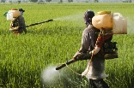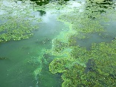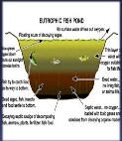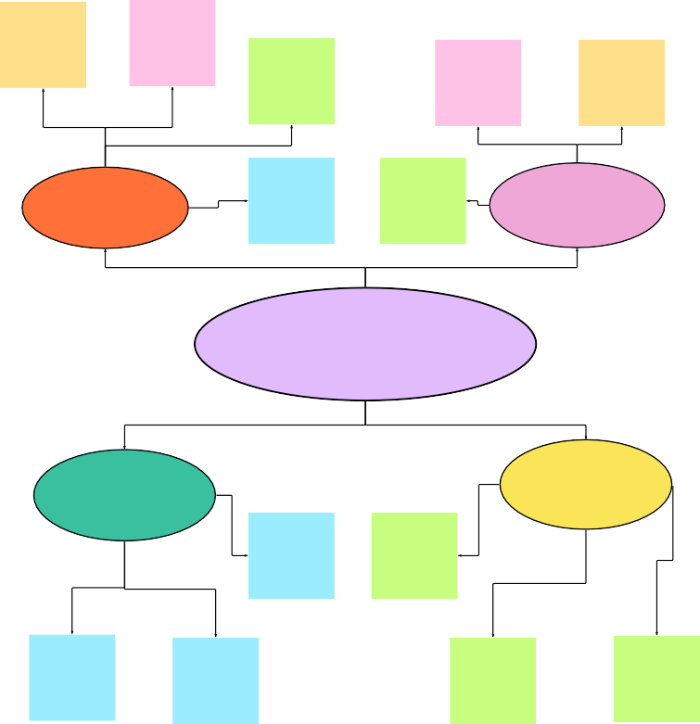

**Feasibility**

[**Share template feedback**](https://muralco.typeform.com/to/CiqaHVat?typeform-source=app.mural.co)

Regardless of their importance, which tasks are more feasible than others? (Cost, time, effort, complexity, etc.)